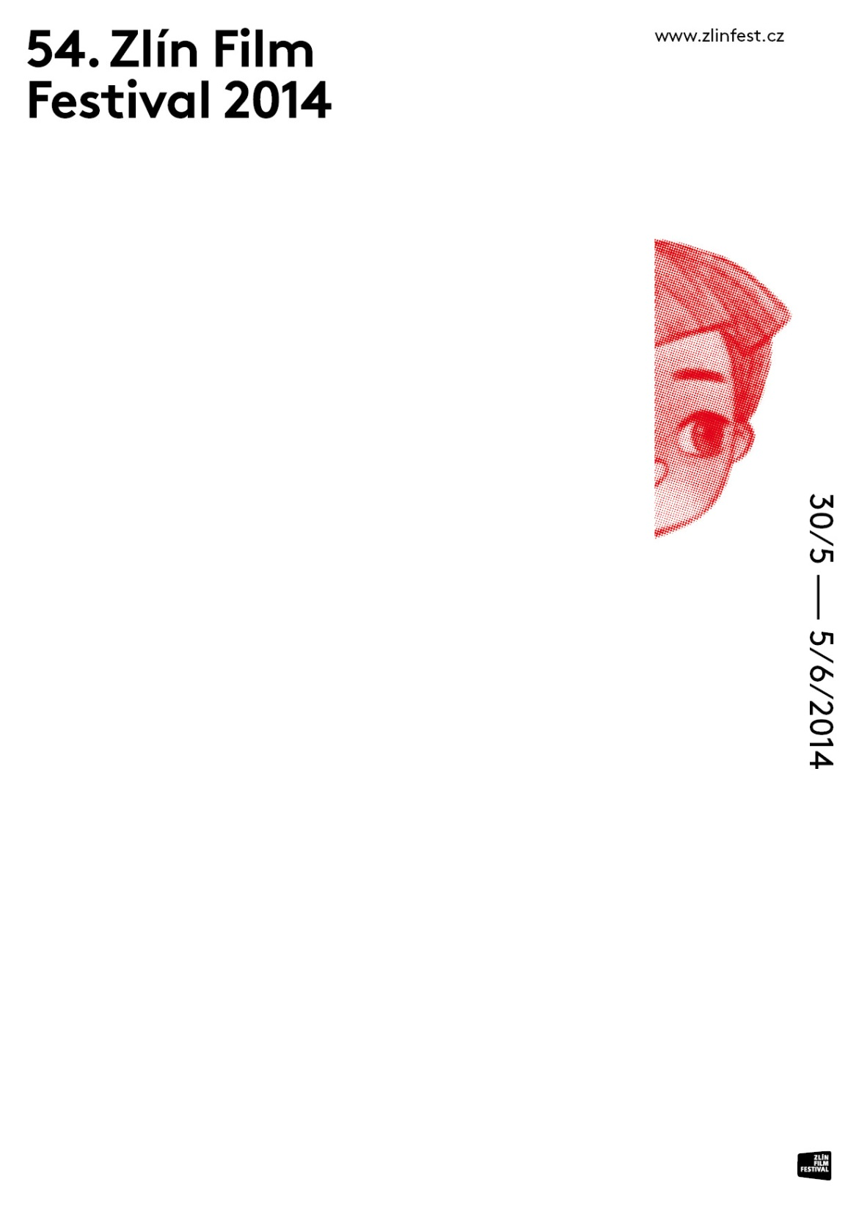
PRESS RELEASE
ISSUED ON THE OCCASION OF THE CLOSING OF THE
54TH ZLÍN FILM FESTIVAL 2014

Zlín, June 4, 2014

TABLE OF CONTENTS:

A Look Back at the 54th edition of ZFF
Acknowledgements to Our Partners and Supporters
Statistics
Personalities

A Look Back at the 54th edition of ZFF
Dear friends of the Zlín Film Festival,
54th ZFF ended well. We have reached our goals and have met our expectations. We really cannot be mad at the bad weather conditions on Monday and Tuesday since the vast majority of our events were held as planned.
All of our films were screened as scheduled. In terms of the supporting programme, we are pleased to announce that our concerts, open air cinema screenings, interactive programs and activates in the Zlín Chateau were extremely well attended. Especially our program in the Zlín Chateau proved to be a successful dramaturgic move. A great success was also daily Red carpet show followed by a Radiožurnál DNES talk show with Vladimír Kroc.
Once more, we have taken a few steps forward. However, we will not lie back on one’s laurels and we will keep improving our program and publicity as always.
Minor deficiencies that appear during every massive event like this were only technical and no human errors were involved. Our team worked excellently and I am proud to be part of it!
I am extremely pleased to announce that the jubilee edition of the 55th ZFF takes place from May 28 (Thursday) to June 6 (Wednesday). We would like to cordially invite all of to Zlín next year again!

Markéta Pášmová – Programme Director

We would like to express our gratitude to the representatives of both public and cultural sectors for their patronage over the 54th ZFF 2014:
Prime Minister of the Czech Republic Bohuslav Sobotka,
H. E. the Ambassador of the Republic of Poland in Prague Grażyna Bernatowicz,
Czech Minister of Culture Daniel Herman,
Czech Committee for UNICEF,
Governor of the Zlín Region Stanislav Mišák,
Mayor of the statutory city of Zlín Miroslav Adámek.

The organizer of the Zlín Film Festival, FILMFEST, s.r.o., would also like to express special thanks to all its partners and supporters, who were absolutely crucial for making it possible for the 54th festival to happen. Among these are:
Co-organizer the statutory city of Zlín,
General partner ENAPO OBCHODNÍ a.s.,
Financial supporters Czech Ministry of Culture, Czech State Fund for the Support and Development of Czech Cinematography, Zlín Regional Authority, Polish Institute in Prague, the town of Otrokovice
Main partners ŠKODA AUTO a.s., DHL Czech Republic, Zlaté Jablko shopping and entertainment center, Impromat
Main media partners Czech Television, Czech Radio, MF DNES, Idnes.cz
Significant media partners CSFD, Radio Kiss, Radio Beat
Stable charitable partner The Drop of Hope Foundation Fund.
Partner of the Days of Polish Cinema - Polish Institute in Prague.
And other partners, supporters, fans and friends.

STATICTICS

ATTENDANCE
Film Screenings 42.000
Supporting Programme (including Zlín Chateau) 65.000
Total Attendance 107.000

Attendance of Zlín Chateau 9.000

FILM PROGRAM
54th ZLÍN FILM FESTIVAL 2014 will screen a total of 365 feature, animated, and combined films from 55 different countries.
Premieres
World premieres 10
International premieres 51
Distribution premieres 2
Czech premieres (first run in Czech cinemas) 212
Total number of films to be shown as premieres 275

Competitive sections: International Competition of Feature Films for Children, International Competition of Feature Films for Youth, International Competition of Animated Films for Children, International Competition of European Feature Film Debuts, Zlín Dog International Student Film Competition

Informative section:
Days of Polish Cinema
New Czech Film and Television Productions
Panorama
Documentaries
Night Horizons
A Thousand and One Nights
Young Stars
Distant Childhoods (new)
In the Shadow of War (new)
Tributes to Bohumil Hrabal & Karel Kachyňa
Grand Prix to Tadeusz Wilkosz

Complete score sheet is included.

JURIES

Main jury:

1. Claudia Landsberger (Netherlands)
2. Mitsuo Tahira (Japan)
3. Dorota Kedzierzawska (Poland)
4. Tomy Wigand (Germany)
5. Monica Wahi (India)
6. Pavlína Němcová (Czech Republic)

Debuts jury:
1. Anna Polívková (Czech Republic)
2. Manlio Castagna (Italy)
3. Marcin Wrona (Poland)

Animation jury:
1. Ralph Graham (United Kingdom)
2. Michaela Pavlátová (Czech Republic)
3. Magdalena Osinska (Poland)

Zlín Dog jury:
1. Aneta Ozorek (Poland)
2. Arkaitz Basterra (Spain)
3. Benjamin Teske (Germany)

ECFA jury:
1. Joan Parson (United Kingdom)
2. Lina Užkuraitytė (Lithuania)
3. Reinhold T. Schöffel (Germany)

Ecumenical jury:
1. Daniela Magálová (Slovakia)
2. Sarah Skoric (Belgium)
3. Charlotte Wells (Sweden)

PERSONALITIES OF THE 54th ZFF 2014
Foreign guests
Marcin Wrona (Poland), screenwriter and director.
Dorota Kędzierzawska (Poland), screenwriter and director.
Massieh Zarrien (United Kingdom), 16-year-old debut actor

Phillipe Muyl (France), screenwriter, director and producer.
Magdalena Berus (Poland), actress

Marian Dziędziel (Poland), film, theater and television actor

Kamil Tkacz (Poland), actor

Wiranu Tembé (Brazil), child actress
Ivo Pietzcker (Germany), child actor

Ilona Herman - an internationally recognized makeup artist of Czech origin

Czech republic/ Slovakia

Daniel Herman
(ministr kultury ČR),
Václav Marhoul, Mahulena Bočanová,
Jiřina Bohdalová,
Martin Dejdar,
Aňa Geislerová,
Jan Hrušínský,
Miluška Šplechtová,
Vladimír Kratina,
Jiří Mádl,
Nela Boudová,
Pavel Trávníček,
Arnošt Goldflam,
Jan Hřebejk,
Václav Vorlíček,
Zdeněk Zelenka,
Michaela Dolinová,
Lenka Krobotová,
Jan Rosák,
Vendula Svobodová,
Josef Dvořák,
Maroš Kramár,
Jana Plodková,
Veronika Kubařová,
Alena Mihulová,
Ondřej Pavelka,
Jitka Ježková,
Hana Vagnerová,
Lukáš Hejlík,
Pavel Řezníček,
Radim Fiala,
Lucie Štěpánková,
Michal Suchánek,
Magda Reifová,
Gabriela Franková (Miss ČR 2014)

DELEGATION PRESENT AT THE 54TH ZFF 2014

INTERNATIONAL COMPETITON OF FEATURE FILMS FOR CHILDREN
Dennis Reinsma (actor) for the film A Christmoose Story (Netherlands)
Wiranu Tembé (actress) for the film Taina - an Amazon Legend (Brasil)
Philippe Muyl (director) for the film The Nightingale (France)
Neele Marie Nickel (actress) for the film Famous Five 3 (Germany)
Rock Demers (producer) for the film The Outlaw League (Canada)
Jiří Mádl (director), Petr Šimčák (actor), Jan Maršál (actor), Miloš Šmídmajer (producer) for the film To See the Sea (Czech reoublic)

INTERNATIONAL COMPETITON OF FEATURE FILMS FOR YOUTH
Runa Greiner (actress), Lea Bloch (actress) for the Sitting Next to Zoe (Switzerland)
Richard Goudreau (director) for the films When We Were Boys (Canada)
Gijs Blom (actor) for the film Boys (Netherlands)

INTERNATIONAL COMPETITION OF EUROPEAN FEATURE FILM DEBUTS
Sebastian Hiort (actor), Lina Leandersson (actress) for the film Broken Hill Blues (Sweden)
Vittorio Gianotti (director), Enrico Audenino (director) for the film Maicol Jecson (Italy)
Alex K. Lee (director), Alix Benezech (actress), Angelo D´Agostino (producer) for the film Maybe Tomorrow
Bruce Goodison (director), Masieh Zarrien (actor) for the film Leave to Remain (United Kingdom)
Ádam Csázsi (director), András Sütő (actor) for the film Land of Storms (Hungary)
Marcin Solarz (director) for the film Deceived (Poland)

YOUNG STARS
Andrzej Tkacz (actor), Kamil Tkacz (actor) for the film Run Boy Run (Poland)
Edward Berger (director), Ivo Pietzcker (actor) for the film Jack (Germany)
Magdalena Berus (actress) for the film Lasting (Poland)
Paula Kalenberg (actor), Tim Oliver Schultz (actor) for the film When Inge Is Dancing (Germany)

PANORAMA
René Vilbre (director), Miikael Ainla (herec), Mariann Vilbre (actress) for the Kid Detectives & The Secret of the White Lady (Estonia)
Joost Ranzijn (director) for the film Urban Rascals (Netherlands)
Veit Helmer (director) for the film Quatsch (Germany)

DAYS OF POLISH CINEMA
Dorota Kedzierzawska (director) for the films Crows and Tomorrow Will Be Better (Poland)
Anna Bluszcz – Wieczur (director) Gabriela Muskala (actress), Marcin Korcz (actor) for the film Being Like Deyna (Poland)
Magdalena Berus (actress) for the films Lasting and Baby Blues (Poland)
Marian Dziedziel (actor) for the films Wedding, The Mole and Rose (Poland)
Kamil Tkacz (actor) for the film Life Feels Good (Poland)
Marcin Wrona (director) for the film The Christening (Poland)

NIGHT HORIZONS
Bartosz Gelner (actor), Mateusz Banasiuk (actor) for the film Floating Skyscrapers (Poland)

INTERNATIONAL COMPETITION OF ANIMATED FILMS FOR CHILDEN
Emilio de la Rosa (director) for the film Origami (Spain)
Makoto Nakamura (director) for the film Cheburaska Goes to the ZOO (Japan)
Lam Ho Tak (director) for the film The Untold & Unseen (Hong Kong)
Deborah Cywiner (director, animator) for the film Eugenia (Israel)
Divyansh Ganjoo (director), Keyur Dekate (director of photography) for the film Wish (India)
Alan Shamsudin (director) for the film The Lighthouse (Czech republic)
Marina Karpova (director) for the film Kolobok (Russia)
Ema Zimonja (director) for the film Berta (Serbia)
Emma McCann (director) for the film Settling (France)
Jörg Halsema (animator) for the film Fred a Anabel (Germany)
Sami Guellai (director) for the film Tulkou (France)
Henrike Rothe (director), Lisa Neubauer (animator) for the film Tibiaq (Germany)
Valoo Toomla (director) for the film Lemonade Tale (Estonia)

SUPPORTING PROGRAMME

ZLÍN CHATEAU – NEW! Children Kingdom – screenings, fun activities, education, interactive activates inside and outside of the Chateau, trampoline
OPEN AIR STAGE – even more activates: film screenings, concerts, DJs, creation of 3D objects, sickling, graffiti, trampoline

ITINEARY of the 17th edition of the project MINISALON – FILM FLAPS 2014
Mladá Boleslav, ŠKODA Museum, exhibition 12/3–4/4 2014
Prague, Hybernia theatre, exhibition 8/4–30/4 2014
Zlín, Golden Apple shopping center, exhibition, 5/5–25/5 2014
Zlín, Congress center Zlín, exhibition, 28/5–2/6 2014
Zlín, Academia centrum – entry hall, auction 3/6 2014 at 13:00 AUCTIONED AMOUNT: 1,331.500Kč

JOURNEY OF THE CINEMATRAIN
15/5 Mladá Boleslav
16/5 Jičín
19/5 Vrchlabí
20/5 Trutnov
21/5 Walbrzych (PL)
22/5 Broumov
23/5 Náchod

26/5 Hradec Králové
27/5 Rychnov nad Kněžnou
28/5 Letohrad
29/5 Olomouc
30/5 Přerov
2/6 Otrokovice
3/6 Zlín

CONCERTS, SHOWS
Ewa Farna, Friday 30/5 The main square (Náměstí Míru)
Xindl X, Saturday 31/5 The main square (Náměstí Míru) (ENAPO day)
Kašpárek v rohlíku, Sunday 1/6 (Radio Junior Day – Czech Radio)
Simona Stašová - Svatopluk Skopal, Sunday 1/6 Zlín Congress Center
Jaroslav Uhlíř, Monday 2/6 , Zlín Congress Center
Chinaski, Monday 2/6 (MF DNES day)
Magda Reifová + Michal Suchánek, Tuesday 3/6 in front of Velké Kino
Bára Basiková (concert for the Nadation Kapka naděje), Tuesday 3/ The main square (Náměstí Míru)
Nebe, Thursday 5/6, The main square (Náměstí Míru)
Lenny, Thursday 5/6, The main square (Náměstí Míru)

BIG INTERACTIVE PROGRAMME AT THE MAIN SQUARE (NÁMĚSTÍ MÍRU)
ENAPO day - Saturday 31/5
Radio Junior day (Czech Radio) – Sunday 1/6
MF DNES day – Monday 2/6
Czech TV day - Wednesday 4/6
Tour 4 Change – Black horses – Thursday 5/6

